GOVERNMENT OF GUJARAT
LUKHDHIRJI ENGINEERING COLLEGE, MORBI
(POLYTECHNIC)
(Approved by AICTE & Affiliated to GTU)
E-Mail: gp-morbi-dte@gujarat.gov.in ,
URL: www.legpm.cteguj.in ,
Address: Near I.T.I. Morbi Campus, Opp. Mahendranagar Overhead Tank,
Ghutu Road, Pipdi Village, Morbi-2, Pin code- 363642

SSIP Cell, L.E. College (Diploma), Morbi

Report on the event of Sensitization of Students regarding SSIP 2.0

Under student startup and innovation policy of Government of Gujarat, L. E. College of Engineering has organized one awareness program for the first year students on 15th September 2022 (Venue: Seminar Room, Ground Flooe, A wing) at 11:00 AM.
Prof. Jignesh Doshi, coordinator of SSIP Cell and Prof. Vishakha Sanghavi , Member of SSIP Cell, have shared knowledge about functions of SSIP cell, organization structure of SSIP committee, SUPPORT SYSTEM OF FUNDING – SSIP, other start-ups/ PoC and features off SSIP 2.0.
Prof. Vishakha Sanghavi also discussed about financial assistance, patent support and mentoring provided by institute SSIP Cell.

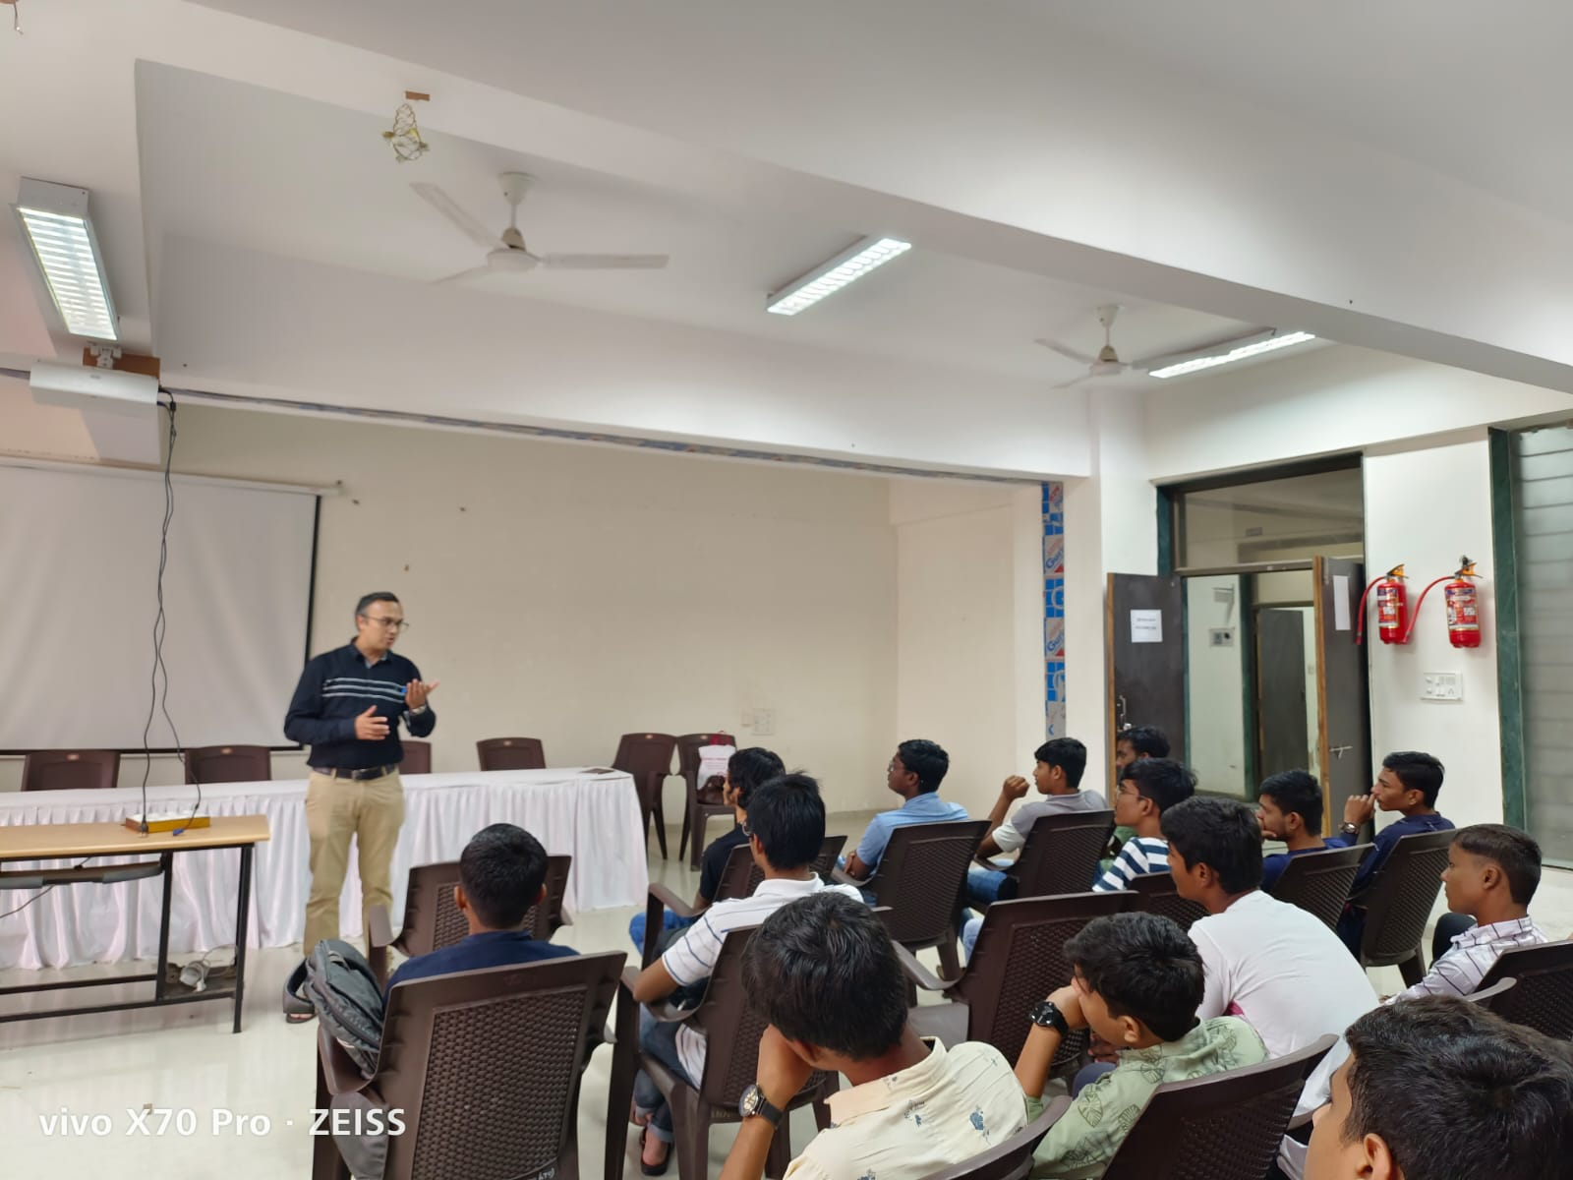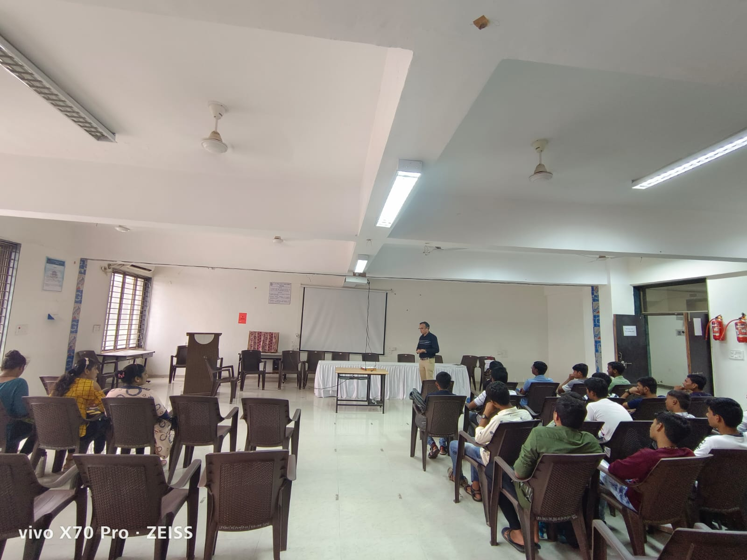

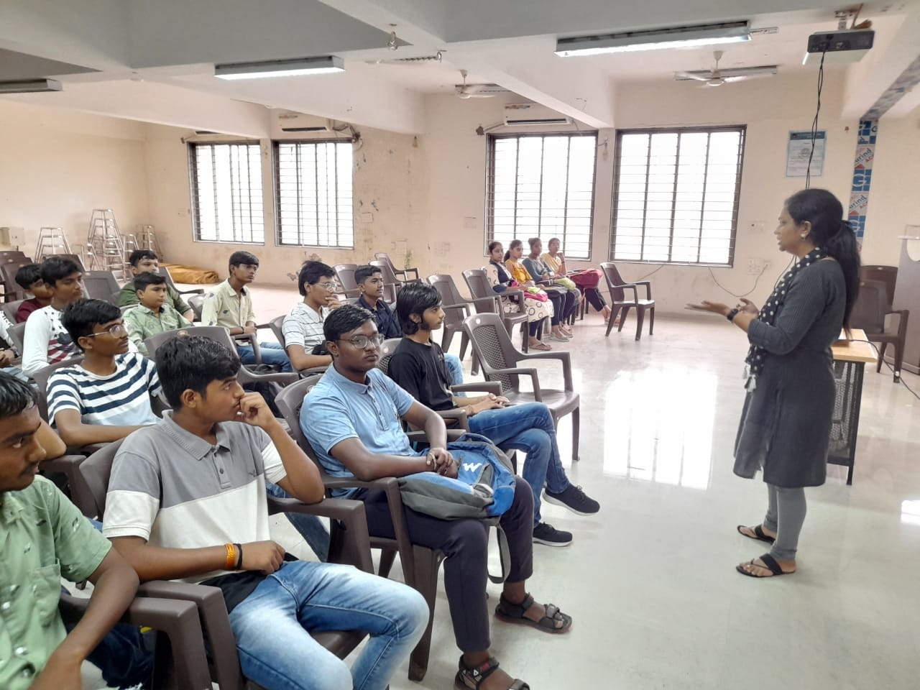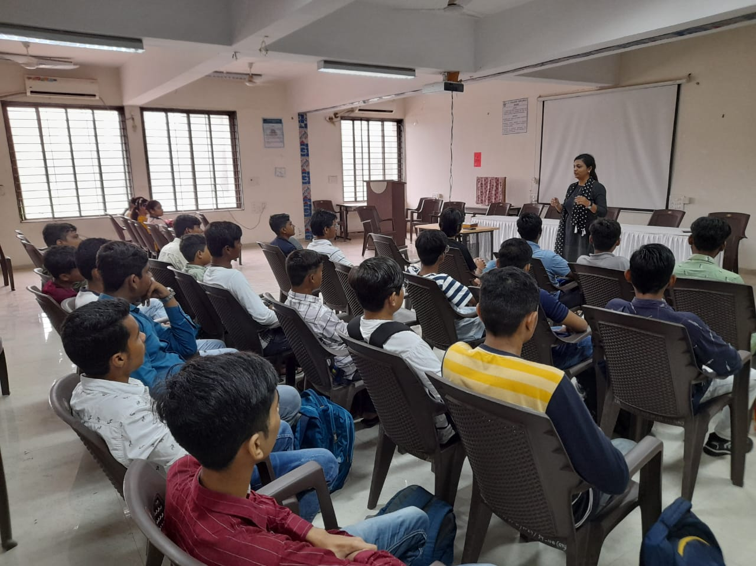

SSIP Coordinator Principal
L.E. College (Diploma), Morbi L.E. College (Diploma), Morbi

